**Descriptive Statistics**

1. Different Types of Data
2. Qualitative Data – Attributes which describes the object under consideration using finite set of values. E.g. colour of shirt, pattern of shirt, size of shirt.

I ) Nominal data – No natural ordering in qualitative Data. (colour, pattern)

II ) Ordinal data – Natural ordering in qualitative Data. (size, rating)

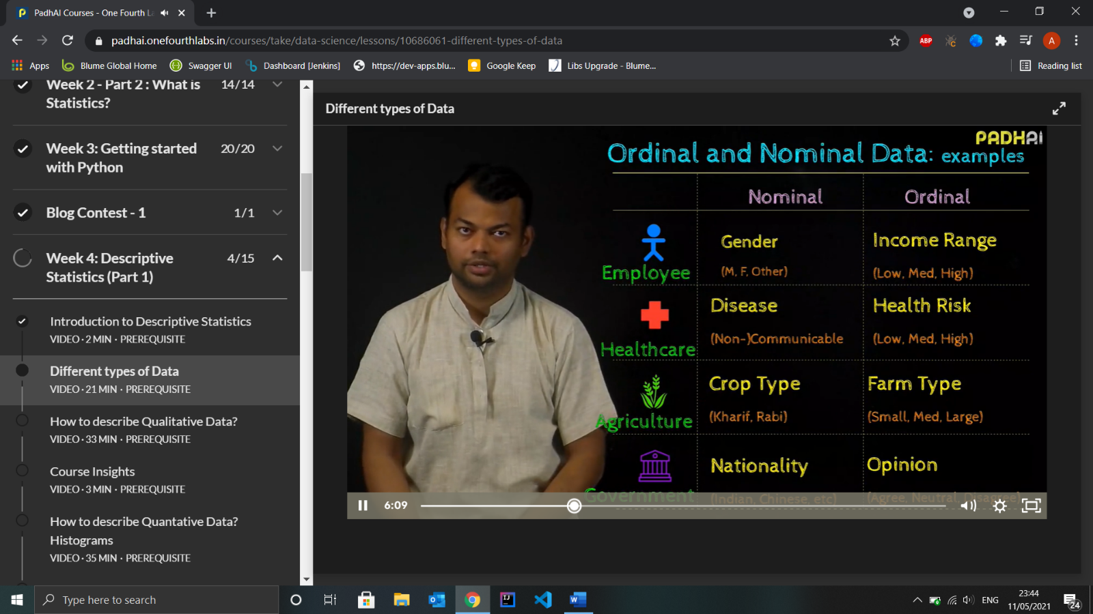

1. Quantitative Data – Attributes which is used to count or measure using numbers and infinite set of values. e.g. price of shirt, discount on price.

I ) Discrete data – Only Integers

II ) Continuous data – All rational Number

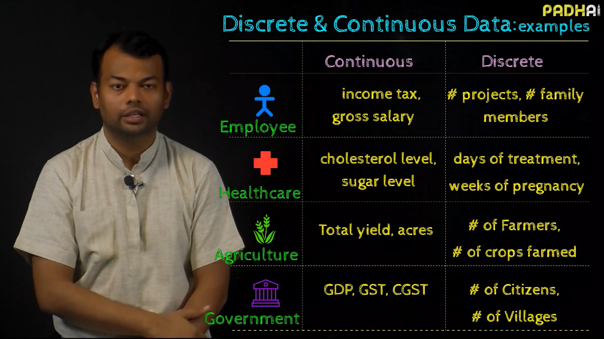

*“****The Type of Statistical Analysis depends on type of variable/data”.***

Exercise

|  |  |  |  |  |
| --- | --- | --- | --- | --- |
| Domain | Ordinal | Nominal | Discrete | Continuous |
| Banking | Employee Review | Gender | No. of employees | Amount of Money |
| Insurance | Employee Review | Gender | No. of Insurance sold | Amount of Money |
| Education | Rank of Toppers | Subjects | No. of courses taught | Fees increment % |
| Healthcare | Rank | Race | No. of patients | Medicine’s weight |
| Sports | Rank of winners | Nationality | No. of medals | Size of field |

1. How to describe Qualitative Data
2. Using Frequency – No. of times an Attribute appears in a sample. **Absolute Frequency** **Plots** are used to represent frequency (Sorted Plot is better for analysis).

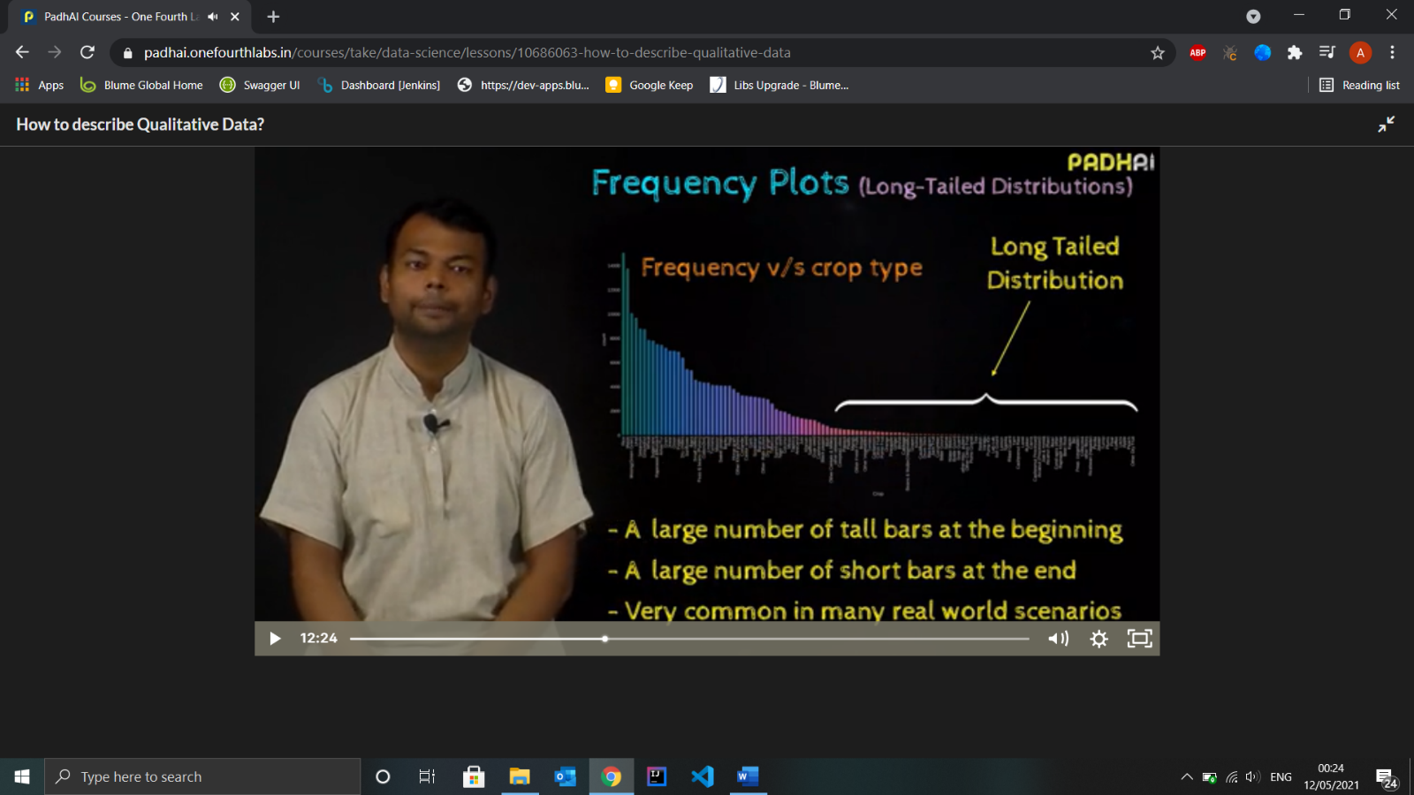

1. Using Relative Frequency – Easier to interpret (e.g. percentages)
2. Grouped Frequency Bar Charts – To compare Different **Sets** of data.

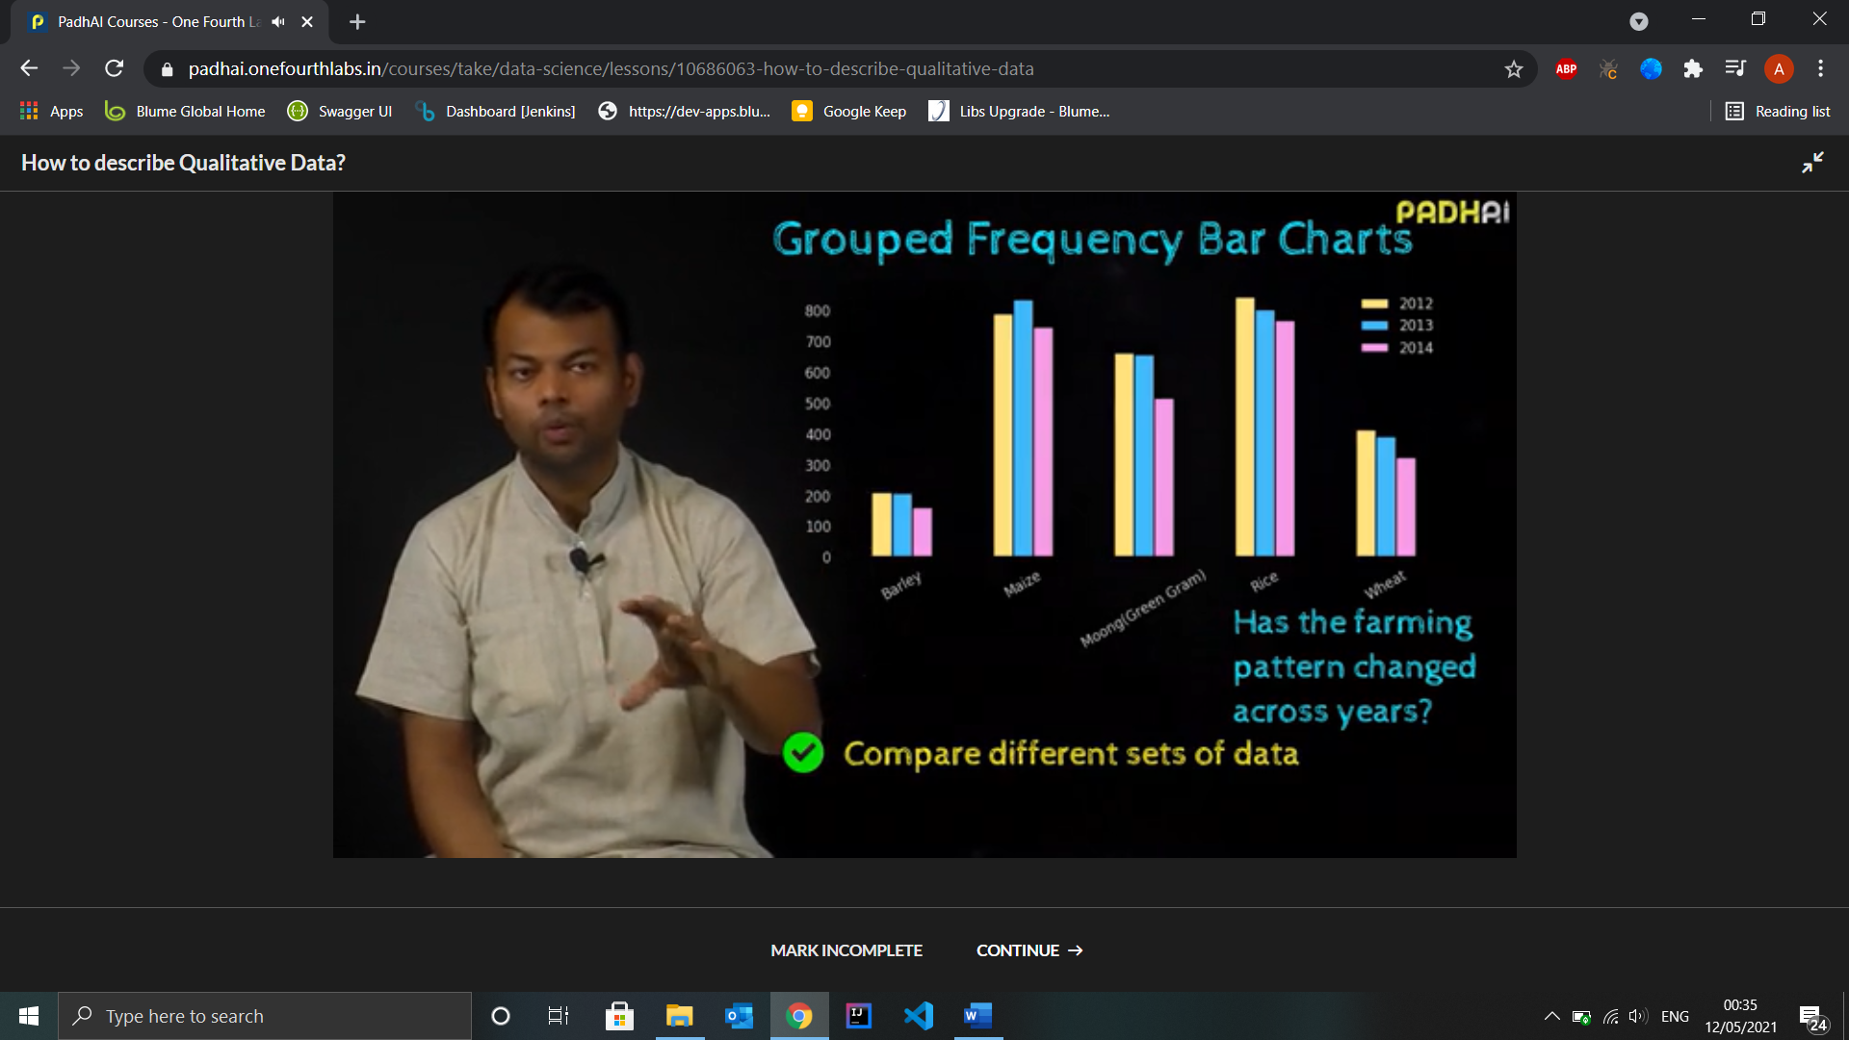

1. Grouped Relative Frequency Bar Charts – Relative way of interpreting.

Use Case in ML: - To analyse Errors ML algorithm, designing features for ML system (e.g., review classification for some product)

Exercise

|  |  |  |
| --- | --- | --- |
| Domain | Long-Tailed Distribution | Uniform Distribution |
| Banking |  |  |
| Insurance |  |  |
| Healthcare |  |  |
| Education |  |  |
| Sports |  |  |
| Business |  |  |

1. How to Describe Quantitative Data
2. Histograms – Ordered X and Y axis
3. Histograms with bins (Ideal for **Continuous Data)**– bin size depends on range of data. Ideal Bin size should neither hide nor reveal too many details.
4. Class-Boundary – Left-end inclusion convention

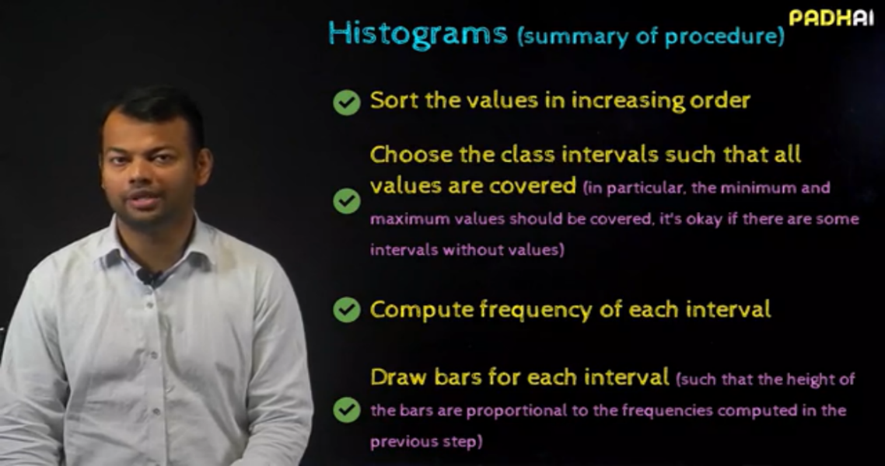

1. Histogram
2. Relative Frequency Histogram

I ) Sort values in increasing order

II ) Choose class interval such that all values are covered

III ) Compute **relative**  frequency of each interval

IV ) Draw bars

1. Compare Multiple Histograms

I ) Draw grouped Bars (no sense of individual pattern)

II ) Use **Frequency Polygons** :- Procedure

1. Sort the values
2. Choose class interval
3. Compute frequency of each interval
4. Compute mid point of each interval and plot the frequency above midpoint



III ) Cumulative Frequency Polygon :- For each class interval, we add the frequencies of all previous intervals

1. Trends in typical Histogram
2. How far are the values spread out
3. Is the data density high in some Intervals
4. Are there gaps in the data
5. Are there outliers in the data
6. Left Skewed Histograms : - Most of the short bars are towards left

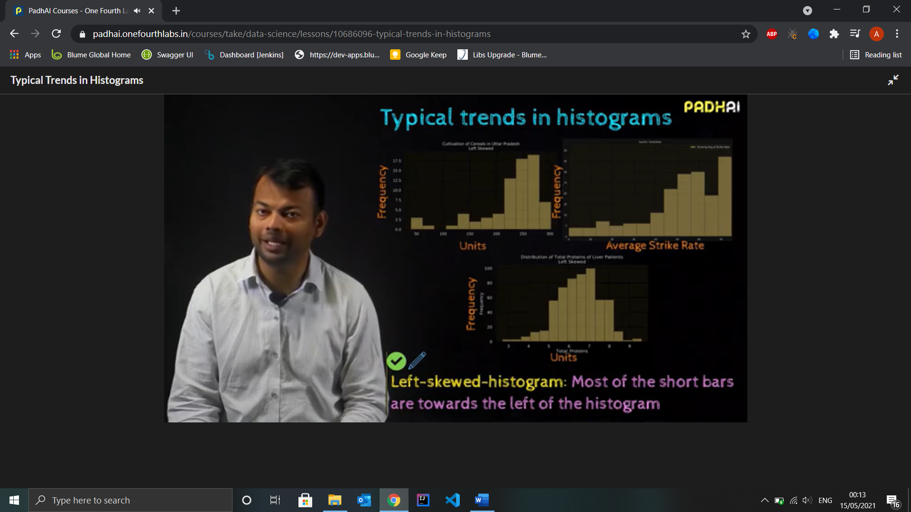

1. Right Skewed Histogram : - Most of the short bars are towards right

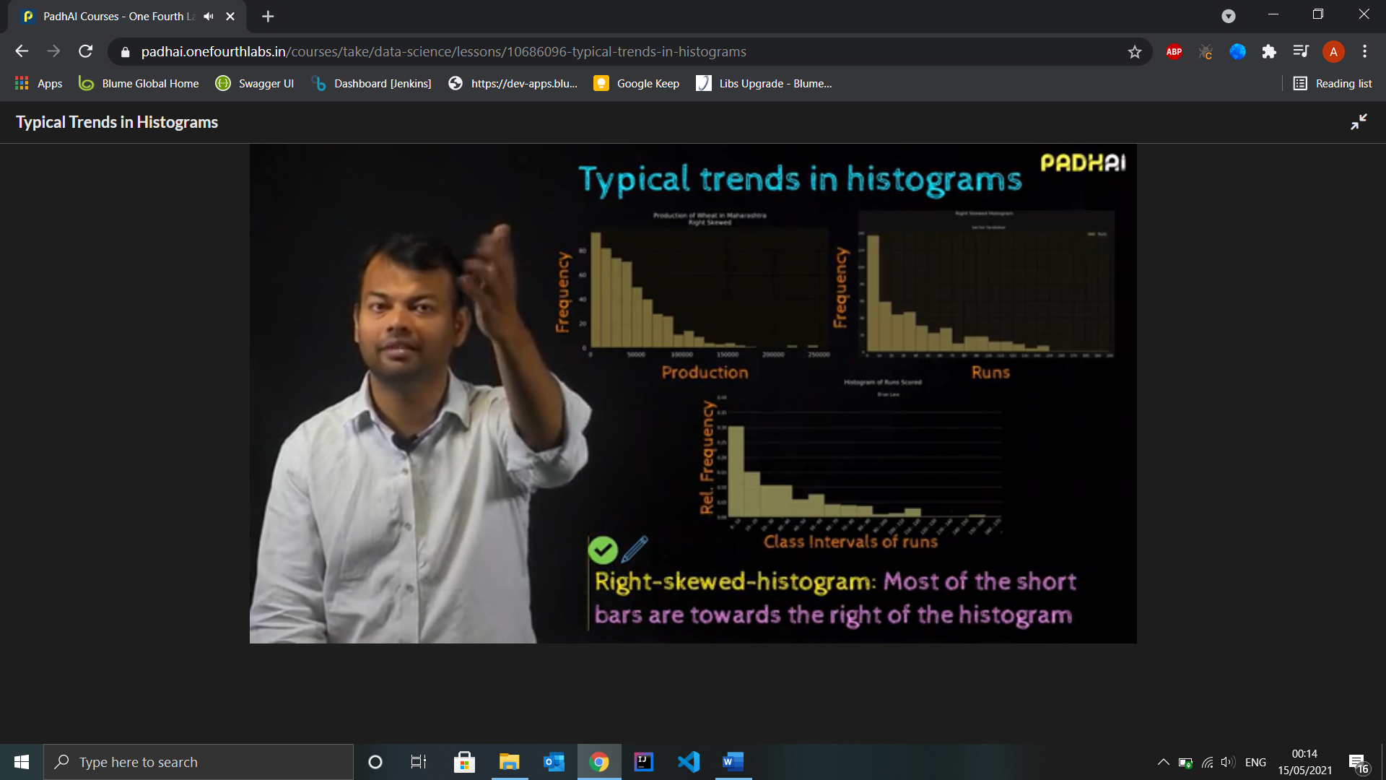

1. Uniform Histogram : almost same height bars
2. Symmetric Histogram :- Bars are almost mirrored image of each other along vertical median

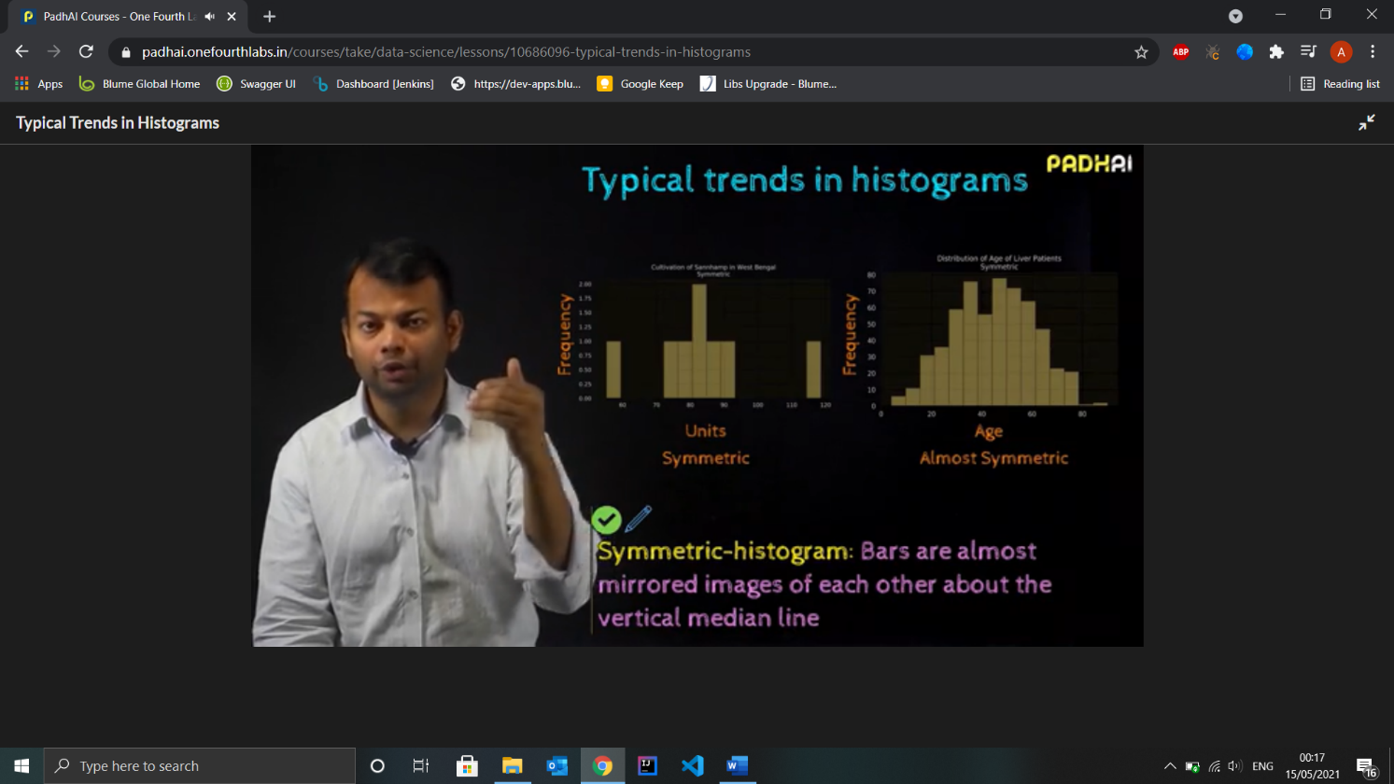

1. Uses of Histograms in ML
2. Identifying Discriminatory Features

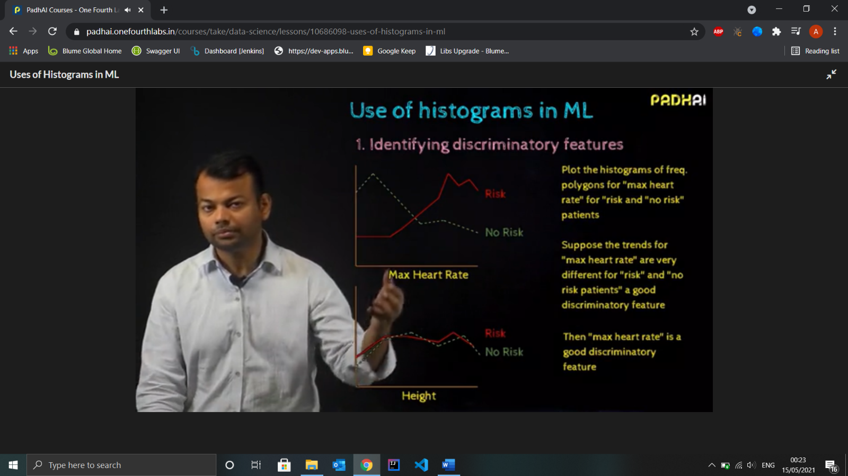

1. Analysing output scores :- For, eg Scoring system, if it is a good response give higher score, if bad give less score

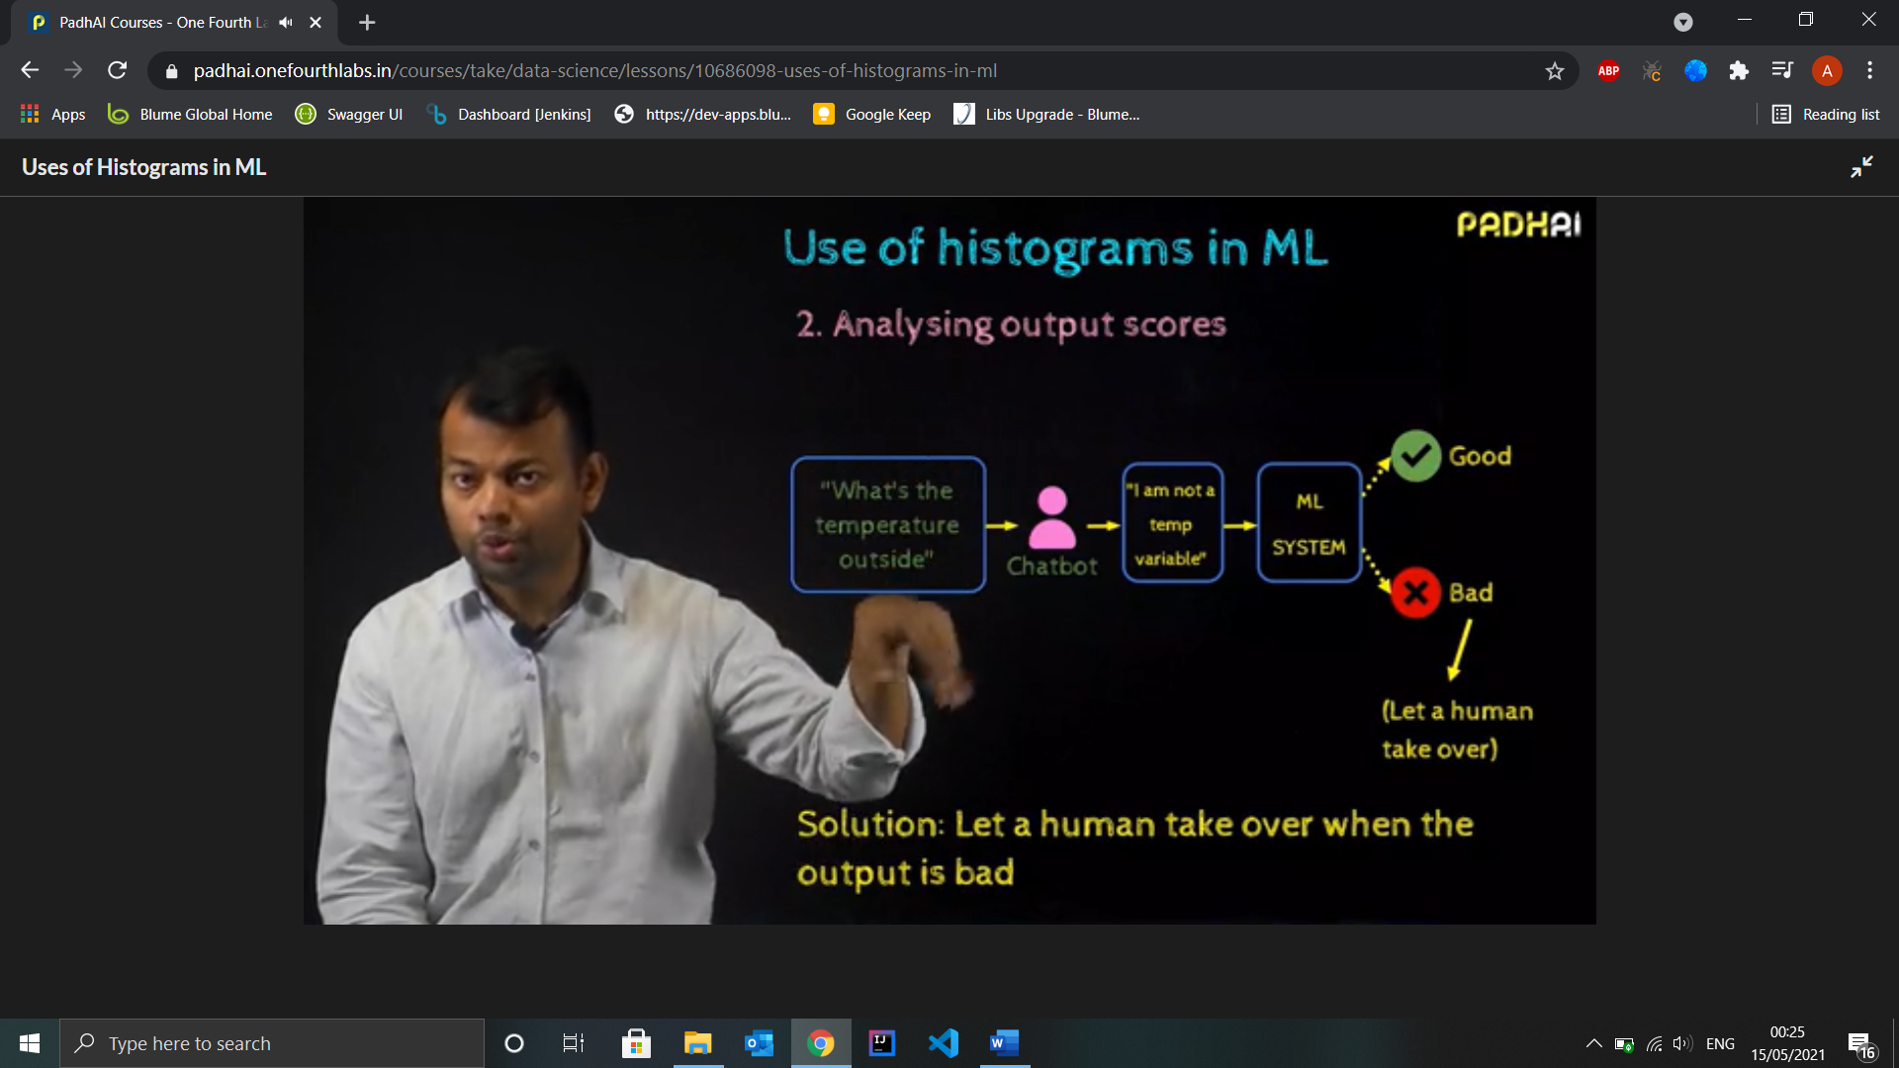

1. Stem and Leaf Plot

Typically used with small data. It represent every number in 2 parts one is called stem other is leaf.

S&L plots looks like histogram when inverted

More Informative : Display’s within group values



Displaying values makes it easier to spot patterns

Use to compare 2 datasets effectively by using back to back S&L plot

1. Scatter Plots

To compare Relationships between variables

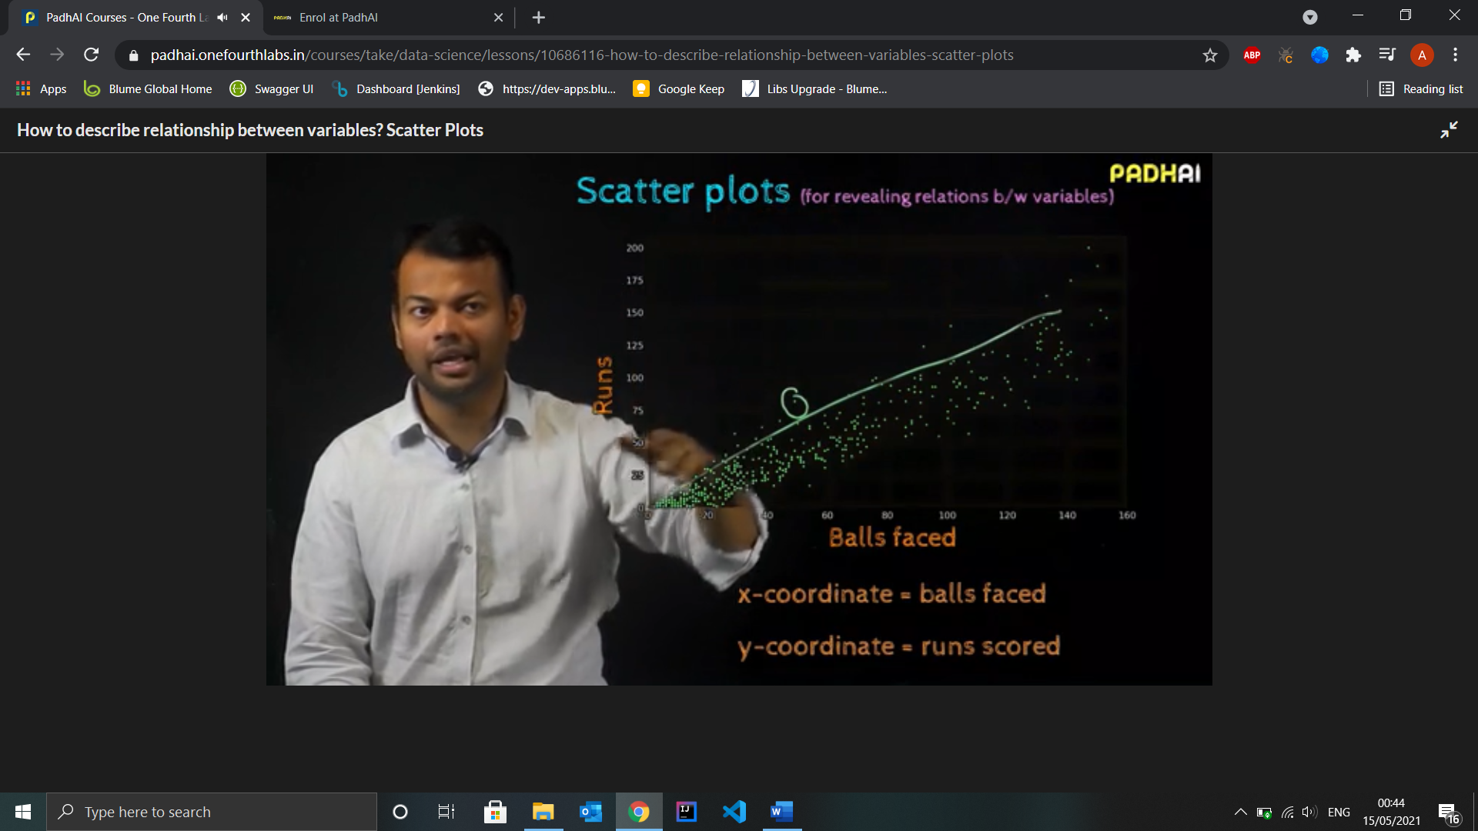

Used Only for Quantitative Data

3 kinds of well known relationships : Linear, Quadratic and Exponential

Use In **ML :**

1. Identify correlated features :- To use uncorrelated or non-redundant features for classification

**Descriptive Statistics – Part 2**

1. Percentiles :- The p percentile of a sample is a value such that p percentage of the values are less than or equal to this value.
2. Sort the Data
3. Compute location of p-th percentile

**Lp  = p/100 (n + 1)**

1. (If in fraction) Find Integer and Fraction Part (Ip and Fp)

**Yp = element at Ip + Fp(element at Ip+1 – element at Ip)**

